Relational Model concept
Relational model can represent as a table with columns and rows. Each row is known as a tuple. Each table of the column has a name or attribute.
Domain: It contains a set of atomic values that an attribute can take.
Attribute: It contains the name of a column in a particular table. Each attribute Ai must have a domain, dom(Ai)
Relational instance: In the relational database system, the relational instance is represented by a finite set of tuples. Relation instances do not have duplicate tuples.
Relational schema: A relational schema contains the name of the relation and name of all columns or attributes.
Relational key: In the relational key, each row has one or more attributes. It can identify the row in the relation uniquely.
Example: STUDENT Relation
NAME | ROLL_NO | PHONE_NO | ADDRESS | AGE
Ram | 14795 | 7305758992 | Noida | 24
Shyam | 12839 | 9026288936 | Delhi | 35
Laxman | 33289 | 8583287182 | Gurugram | 20
Mahesh | 27857 | 7086819134 | Ghaziabad | 27
Ganesh | 17282 | 9028 9i3988 | Delhi | 40
- In the given table, NAME, ROLL_NO, PHONE_NO, ADDRESS, and AGE are the attributes.
- The instance of schema STUDENT has 5 tuples.
- t3 = <Laxman, 33289, 8583287182, Gurugram, 20>

Properties of Relations
- Name of the relation is distinct from all other relations.
- Each relation cell contains exactly one atomic (single) value
- Each attribute contains a distinct name
- Attribute domain has no significance
- tuple has no duplicate value
- Order of tuple can have a different sequence

Keys in DBMS-

A key is a set of attributes that can identify each tuple uniquely in the given relation.

Different Types Of Keys in DBMS-

There are following 10 important keys in DBMS-

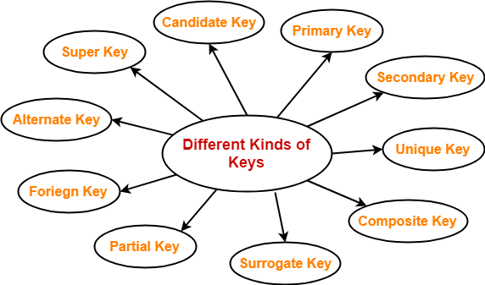

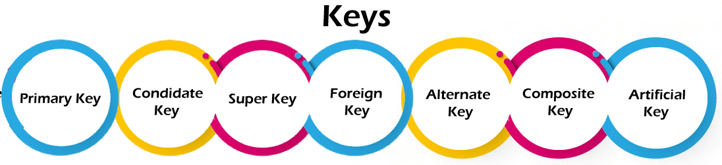

- Super key
- Candidate key
- Primary key
- Alternate key
- Foreign key
- Partial key
- Composite key
- Unique key
- Surrogate key

NOTE-

Before proceeding further, Kindly note-
- The terms ‘relation’ and ‘table’ are used interchangeably.
- The terms ‘tuple’ and ‘record’ are used interchangeably.

1. Super Key-

- A super key is a set of attributes that can identify each tuple uniquely in the given relation.
- A super key is not restricted to have any specific number of attributes.
- Thus, a super key may consist of any number of attributes.

Example-

Consider the following Student schema-
Student ( roll , name , sex , age , address , class , section )

Given below are the examples of super keys since each set can uniquely identify each student in the Student table-
- ( roll , name , sex , age , address , class , section )
- ( class , section , roll )
- (class , section , roll , sex )
- ( name , address )

NOTE-

All the attributes in a super key are definitely sufficient to identify each tuple uniquely in the given relation but all of them may not be necessary.

2. Candidate Key-

A minimal super key is called as a candidate key.
OR
A set of minimal attribute(s) that can identify each tuple uniquely in the given relation is called as a candidate key.

Example-

Consider the following Student schema-
Student ( roll , name , sex , age , address , class , section )

Given below are the examples of candidate keys since each set consists of minimal attributes required to identify each student uniquely in the Student table-
- ( class , section , roll )
- ( name , address )

NOTES-

- All the attributes in a candidate key are sufficient as well as necessary to identify each tuple uniquely.
- Removing any attribute from the candidate key fails in identifying each tuple uniquely.
- The value of candidate key must always be unique.
- The value of candidate key can never be NULL.
- It is possible to have multiple candidate keys in a relation.
- Those attributes which appears in some candidate key are called as prime attributes.

3. Primary Key-

A primary key is a candidate key that the database designer selects while designing the database.
OR
Candidate key that the database designer implements is called as a primary key.

NOTES-

- The value of primary key can never be NULL.
- The value of primary key must always be unique.
- The values of primary key can never be changed i.e. no updation is possible.
- The value of primary key must be assigned when inserting a record.
- A relation is allowed to have only one primary key.

Remember-

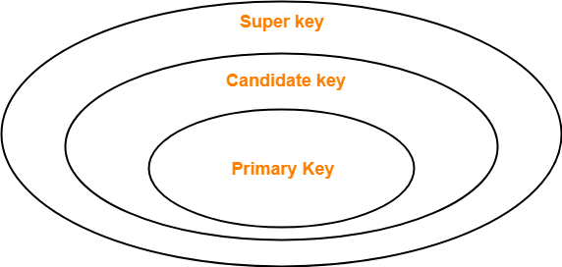

4. Alternate Key-

Candidate keys that are left unimplemented or unused after implementing the primary key are called as alternate keys.
OR
Unimplemented candidate keys are called as alternate keys.

5. Foreign Key-

- An attribute ‘X’ is called as a foreign key to some other attribute ‘Y’ when its values are dependent on the values of attribute ‘Y’.
- The attribute ‘X’ can assume only those values which are assumed by the attribute ‘Y’.
- Here, the relation in which attribute ‘Y’ is present is called as the referenced relation.
- The relation in which attribute ‘X’ is present is called as the referencing relation.
- The attribute ‘Y’ might be present in the same table or in some other table.

Example-

Consider the following two schemas-
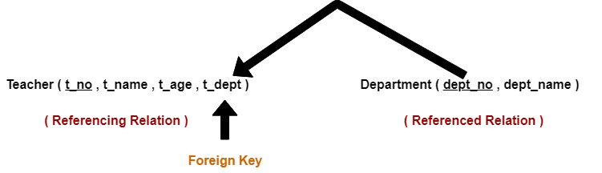

Here, t_dept can take only those values which are present in dept_no in Department table since only those departments actually exist.

NOTES-

- Foreign key references the primary key of the table.
- Foreign key can take only those values which are present in the primary key of the referenced relation.
- Foreign key may have a name other than that of a primary key.
- Foreign key can take the NULL value.
- There is no restriction on a foreign key to be unique.
- In fact, foreign key is not unique most of the time.
- Referenced relation may also be called as the master table or primary table.
- Referencing relation may also be called as the foreign table.

6. Partial Key-

- Partial key is a key using which all the records of the table can not be identified uniquely.
- However, a bunch of related tuples can be selected from the table using the partial key.

Example-

Consider the following schema-
Department ( Emp_no , Dependent_name , Relation )

Emp_no | Dependent_name | Relation
E1 | Suman | Mother
E1 | Ajay | Father
E2 | Vijay | Father
E2 | Ankush | Son

Here, using partial key Emp_no, we can not identify a tuple uniquely but we can select a bunch of tuples from the table.

7. Composite Key-

A primary key comprising of multiple attributes and not just a single attribute is called as a composite key.

8. Unique Key-

Unique key is a key with the following properties-
- It is unique for all the records of the table.
- Once assigned, its value can not be changed i.e. it is non-updatable.
- It may have a NULL value.

Example-

The best example of unique key is Adhaar Card Numbers.
- The Adhaar Card Number is unique for all the citizens (tuples) of India (table).
- If it gets lost and another duplicate copy is issued, then the duplicate copy always has the same number as before.
- Thus, it is non-updatable.
- Few citizens may not have got their Adhaar cards, so for them its value is NULL.

9. Surrogate Key-

Surrogate key is a key with the following properties-
- It is unique for all the records of the table.
- It is updatable.
- It can not be NULL i.e. it must have some value.

Example-

Mobile Number of students in a class where every student owns a mobile phone.

Integrity Constraints
- Integrity constraints are a set of rules. It is used to maintain the quality of information.
- Integrity constraints ensure that the data insertion, updating, and other processes have to be performed in such a way that data integrity is not affected.
- Thus, integrity constraint is used to guard against accidental damage to the database.

Types of Integrity Constraint
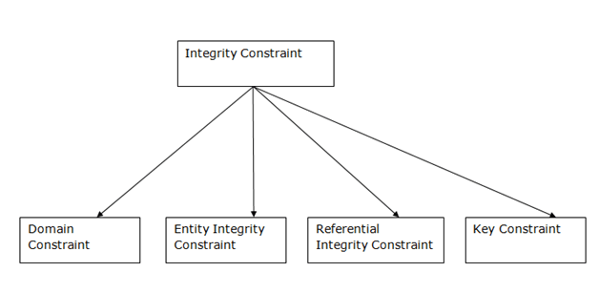

1. Domain constraints
- Domain constraints can be defined as the definition of a valid set of values for an attribute.
- The data type of domain includes string, character, integer, time, date, currency, etc. The value of the attribute must be available in the corresponding domain.
Example:
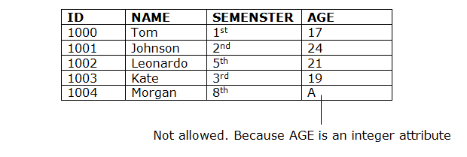

2. Entity integrity constraints
- The entity integrity constraint states that primary key value can't be null.
- This is because the primary key value is used to identify individual rows in relation and if the primary key has a null value, then we can't identify those rows.
- A table can contain a null value other than the primary key field.
Example:
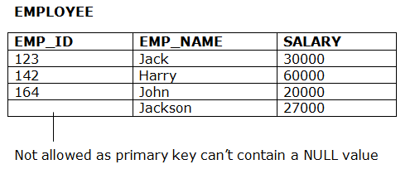

3. Referential Integrity Constraints
- A referential integrity constraint is specified between two tables.
- In the Referential integrity constraints, if a foreign key in Table 1 refers to the Primary Key of Table 2, then every value of the Foreign Key in Table 1 must be null or be available in Table 2.
Example:
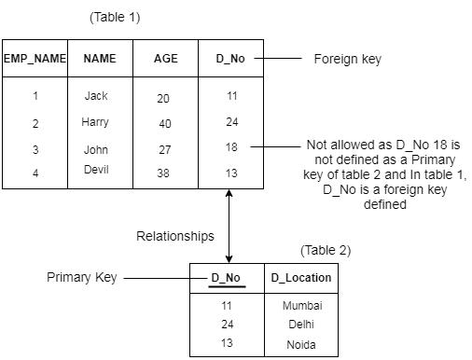

4. Key constraints
- Keys are the entity set that is used to identify an entity within its entity set uniquely.
- An entity set can have multiple keys, but out of which one key will be the primary key. A primary key can contain a unique and null value in the relational table.
Example:
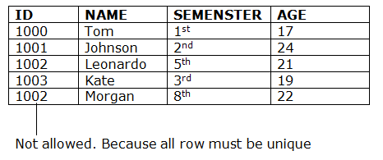

Relational Algebra
Relational algebra is a procedural query language. It gives a step by step process to obtain the result of the query. It uses operators to perform queries.

Types of Relational operation
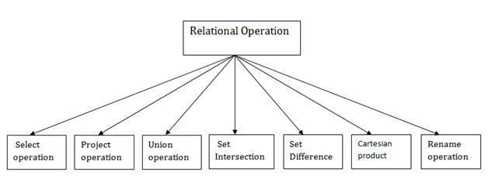

1. Select Operation:
- The select operation selects tuples that satisfy a given predicate.
- It is denoted by sigma (σ).
- Notation: σ p(r)
Where:
σ is used for selection prediction
r is used for relation
p is used as a propositional logic formula which may use connectors like: AND OR and NOT. These relational can use as relational operators like =, ≠, ≥, <, >, ≤.
For example: LOAN Relation
BRANCH_NAME | LOAN_NO | AMOUNT
Downtown | L-17 | 1000
Redwood | L-23 | 2000
Perryride | L-15 | 1500
Downtown | L-14 | 1500
Mianus | L-13 | 500
Roundhill | L-11 | 900
Perryride | L-16 | 1300
Input:
- σ BRANCH_NAME="perryride" (LOAN)
Output:
BRANCH_NAME | LOAN_NO | AMOUNT
Perryride | L-15 | 1500
Perryride | L-16 | 1300

2. Project Operation:
- This operation shows the list of those attributes that we wish to appear in the result. Rest of the attributes are eliminated from the table.
- It is denoted by ∏.
- Notation: ∏ A1, A2, An (r)
Where
A1, A2, A3 is used as an attribute name of relation r.
Example: CUSTOMER RELATION
NAME | STREET | CITY
Jones | Main | Harrison
Smith | North | Rye
Hays | Main | Harrison
Curry | North | Rye
Johnson | Alma | Brooklyn
Brooks | Senator | Brooklyn
Input:
- ∏ NAME, CITY (CUSTOMER)
Output:
NAME | CITY
Jones | Harrison
Smith | Rye
Hays | Harrison
Curry | Rye
Johnson | Brooklyn
Brooks | Brooklyn

3. Union Operation:
- Suppose there are two tuples R and S. The union operation contains all the tuples that are either in R or S or both in R & S.
- It eliminates the duplicate tuples. It is denoted by ∪.
- Notation: R ∪ S
A union operation must hold the following condition:
- R and S must have the attribute of the same number.
- Duplicate tuples are eliminated automatically.

Example:
DEPOSITOR RELATION
CUSTOMER_NAME | ACCOUNT_NO
Johnson | A-101
Smith | A-121
Mayes | A-321
Turner | A-176
Johnson | A-273
Jones | A-472
Lindsay | A-284
BORROW RELATION
CUSTOMER_NAME | LOAN_NO
Jones | L-17
Smith | L-23
Hayes | L-15
Jackson | L-14
Curry | L-93
Smith | L-11
Williams | L-17
Input:
- ∏ CUSTOMER_NAME (BORROW) ∪ ∏ CUSTOMER_NAME (DEPOSITOR)
Output:
CUSTOMER_NAME
Johnson
Smith
Hayes
Turner
Jones
Lindsay
Jackson
Curry
Williams
Mayes

4. Set Intersection:
- Suppose there are two tuples R and S. The set intersection operation contains all tuples that are in both R & S.
- It is denoted by intersection ∩.
- Notation: R ∩ S
Example: Using the above DEPOSITOR table and BORROW table
Input:
- ∏ CUSTOMER_NAME (BORROW) ∩ ∏ CUSTOMER_NAME (DEPOSITOR)
Output:
CUSTOMER_NAME
Smith
Jones

5. Set Difference:
- Suppose there are two tuples R and S. The set intersection operation contains all tuples that are in R but not in S.
- It is denoted by intersection minus (-).
- Notation: R - S
Example: Using the above DEPOSITOR table and BORROW table
Input:
- ∏ CUSTOMER_NAME (BORROW) - ∏ CUSTOMER_NAME (DEPOSITOR)
Output:
CUSTOMER_NAME
Jackson
Hayes
Willians
Curry

6. Cartesian product
- The Cartesian product is used to combine each row in one table with each row in the other table. It is also known as a cross product.
- It is denoted by X.
- Notation: E X D

Example:
EMPLOYEE
EMP_ID | EMP_NAME | EMP_DEPT
1 | Smith | A
2 | Harry | C
3 | John | B
DEPARTMENT
DEPT_NO | DEPT_NAME
A | Marketing
B | Sales
C | Legal
Input:
- EMPLOYEE X DEPARTMENT
Output:
EMP_ID | EMP_NAME | EMP_DEPT | DEPT_NO | DEPT_NAME
1 | Smith | A | A | Marketing
1 | Smith | A | B | Sales
1 | Smith | A | C | Legal
2 | Harry | C | A | Marketing
2 | Harry | C | B | Sales
2 | Harry | C | C | Legal
3 | John | B | A | Marketing
3 | John | B | B | Sales
3 | John | B | C | Legal

7. Rename Operation:
The rename operation is used to rename the output relation. It is denoted by rho (ρ).
Example: We can use the rename operator to rename STUDENT relation to STUDENT1.
- ρ(STUDENT1, STUDENT)

Join Operations:
A Join operation combines related tuples from different relations, if and only if a given join condition is satisfied. It is denoted by ⋈.

Example:
EMPLOYEE
EMP_CODE | EMP_NAME
101 | Stephan
102 | Jack
103 | Harry
SALARY
EMP_CODE | SALARY
101 | 50000
102 | 30000
103 | 25000
- Operation: (EMPLOYEE ⋈ SALARY)
Result:
4696History of Java
EMP_CODE | EMP_NAME | SALARY
101 | Stephan | 50000
102 | Jack | 30000
103 | Harry | 25000

Types of Join operations:
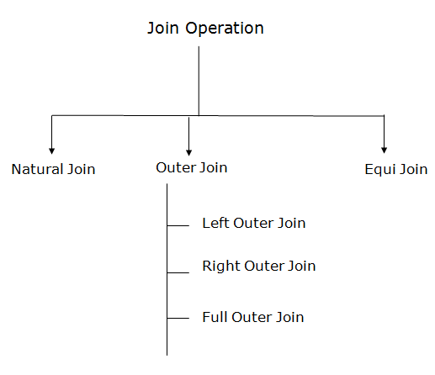

1. Natural Join:
- A natural join is the set of tuples of all combinations in R and S that are equal on their common attribute names.
- It is denoted by ⋈.
Example: Let's use the above EMPLOYEE table and SALARY table:
Input:
- ∏EMP_NAME, SALARY (EMPLOYEE ⋈ SALARY)
Output:
EMP_NAME | SALARY
Stephan | 50000
Jack | 30000
Harry | 25000

2. Outer Join:
The outer join operation is an extension of the join operation. It is used to deal with missing information.
Example:
EMPLOYEE
EMP_NAME | STREET | CITY
Ram | Civil line | Mumbai
Shyam | Park street | Kolkata
Ravi | M.G. Street | Delhi
Hari | Nehru nagar | Hyderabad
FACT_WORKERS
EMP_NAME | BRANCH | SALARY
Ram | Infosys | 10000
Shyam | Wipro | 20000
Kuber | HCL | 30000
Hari | TCS | 50000
Input:
- (EMPLOYEE ⋈ FACT_WORKERS)
Output:
EMP_NAME | STREET | CITY | BRANCH | SALARY
Ram | Civil line | Mumbai | Infosys | 10000
Shyam | Park street | Kolkata | Wipro | 20000
Hari | Nehru nagar | Hyderabad | TCS | 50000
An outer join is basically of three types:
- Left outer join
- Right outer join
- Full outer join

a. Left outer join:
- Left outer join contains the set of tuples of all combinations in R and S that are equal on their common attribute names.
- In the left outer join, tuples in R have no matching tuples in S.
- It is denoted by ⟕.
Example: Using the above EMPLOYEE table and FACT_WORKERS table
Input:
- EMPLOYEE ⟕ FACT_WORKERS
EMP_NAME | STREET | CITY | BRANCH | SALARY
Ram | Civil line | Mumbai | Infosys | 10000
Shyam | Park street | Kolkata | Wipro | 20000
Hari | Nehru street | Hyderabad | TCS | 50000
Ravi | M.G. Street | Delhi | NULL | NULL

b. Right outer join:
- Right outer join contains the set of tuples of all combinations in R and S that are equal on their common attribute names.
- In right outer join, tuples in S have no matching tuples in R.
- It is denoted by ⟖.
Example: Using the above EMPLOYEE table and FACT_WORKERS Relation
Input:
- EMPLOYEE ⟖ FACT_WORKERS
Output:
EMP_NAME | BRANCH | SALARY | STREET | CITY
Ram | Infosys | 10000 | Civil line | Mumbai
Shyam | Wipro | 20000 | Park street | Kolkata
Hari | TCS | 50000 | Nehru street | Hyderabad
Kuber | HCL | 30000 | NULL | NULL

c. Full outer join:
- Full outer join is like a left or right join except that it contains all rows from both tables.
- In full outer join, tuples in R that have no matching tuples in S and tuples in S that have no matching tuples in R in their common attribute name.
- It is denoted by ⟗.
Example: Using the above EMPLOYEE table and FACT_WORKERS table
Input:
- EMPLOYEE ⟗ FACT_WORKERS
Output:
EMP_NAME | STREET | CITY | BRANCH | SALARY
Ram | Civil line | Mumbai | Infosys | 10000
Shyam | Park street | Kolkata | Wipro | 20000
Hari | Nehru street | Hyderabad | TCS | 50000
Ravi | M.G. Street | Delhi | NULL | NULL
Kuber | NULL | NULL | HCL | 30000

3. Equi join:
It is also known as an inner join. It is the most common join. It is based on matched data as per the equality condition. The equi join uses the comparison operator (=).
Example:
CUSTOMER RELATION
CLASS_ID | NAME
1 | John
2 | Harry
3 | Jackson
PRODUCT
PRODUCT_ID | CITY
1 | Delhi
2 | Mumbai
3 | Noida
Input:
- CUSTOMER ⋈ PRODUCT
Output:
CLASS_ID | NAME | PRODUCT_ID | CITY
1 | John | 1 | Delhi
2 | Harry | 2 | Mumbai
3 | Harry | 3 | Noida

